LAB 9: 20 points
Register File

PROJECT DESCRIPTION

One of the main goals of this course is to complete MIPS Single Cycle Processor in simulation. Each component in the processor plays an important role in executing instructions. One of the most important components is the Control Unit. In this lab, we will see how the ALU Decoder and the Main Decoder are mapped down to the gate level.
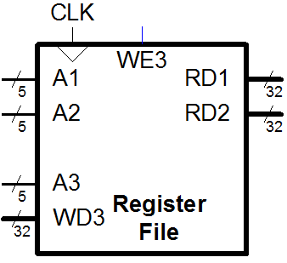
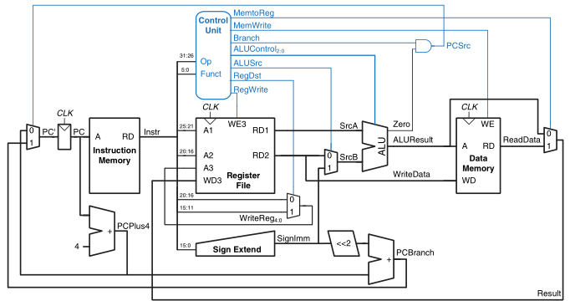

Section 1: Create the RegisterFile Verilog Module
Use the following Verilog module definition:

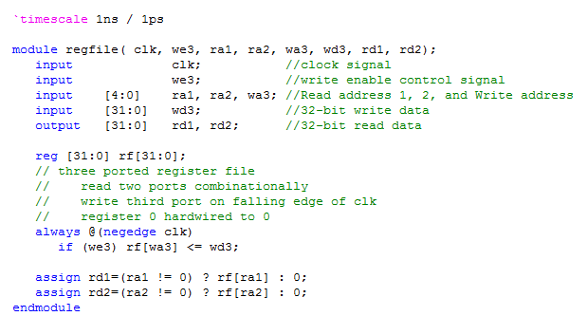

Be sure to include the code comments in your verilog module.

Generate RTL schematic of your regfile to ensure it has been created correctly (refer to the previous lab if forget to generate the RTL schametic). Address any Errors or Warnings that may appear during the generation of the RTL schematic.
Section 2: Create the Register File Verilog test fixture

Create a Verilog Test Fixture named regfile_Tester.

Since the Register File is synchronous logic, we will need a clock pulse generator. We will make one in the tester by inserting a line of code after our regfile module instantiation:

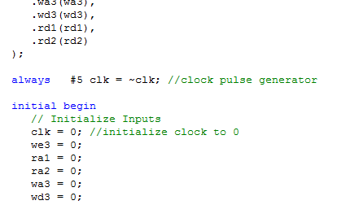
Initialize all inputs as shown on the left with the given assignment statements before writing your test cases.

A table like the one shown below can help you form your test cases:
Test Case | Description | Input values
Test Case | Description | we3 | ra1 | ra2 | wa3 | wd3
0 | Write your SID in hex to register 10  Read register 10 value on rd1 output | 1 | 10 | X | 10 | 32’h00059460
1 | Write your hex SID multiplied by 3 to register 20  Read register 20 value on rd2 output | 1 | X | 20 | 20 | 32’h0010bd20
2 | Write SID multiplied by 10 to register 30  Read register 30 value on rd2 output
3 | Write SID subtracted by 2 to register 22  Read register 22 value on rd1 output
Be sure to use your student ID instead of the one that is shown

Sample code for Test Case 0 is shown below for reference:
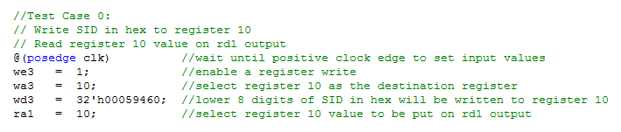
Use comments in all your test cases in the format shown above.

Be sure to use the $stop; system call after the last test case!
Section 3: regfile Simulation

Correct simulation waveform is shown (according to my SID) for the first two regfile test cases is shown below, all values are in hex:

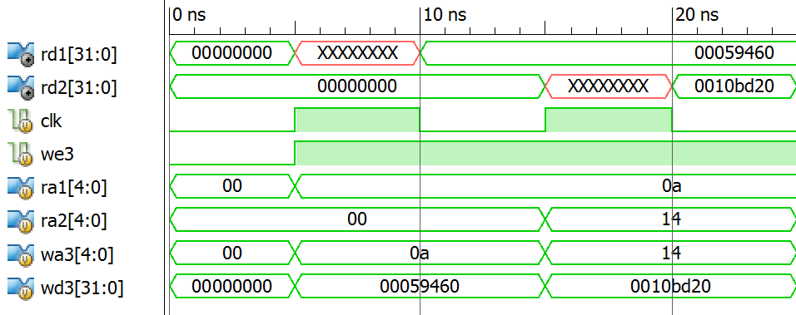

Test case 1:
Register 10 = SID in hex
Test case 2:
Register 10 = 3*SID in hex

Notice that the rd1 output is equal to XXXXXXXX in the simulation waveforms from time 5ns to 10ns. This is because the read address 1 (ra1) input is set to 10 at simulation time 5ns. Register 10 is being read before it has been initialized.

On the first negative clock edge (occurring at simulation time 10ns) the value of my student ID is written to register 10 and then the output rd1 indicates that register 10 now contains my student ID.

Save all the Verilog Source Files in this project, they will be used in future projects.

Lab 9 Report: Submit a single PDF to beachboard with the following contents.
- Title Page
  - CECS 225
  - Lab 9
  - Your Name
- Section 1: regfile Verilog module source (be sure to include code comments) +regfile RTL schematic
- Section 2: regfile Verilog Test Fixture (be sure to include code comments)
- Section 3: regfile Simulation Waveform Screenshot clearly showing correct results
- Section 4: regfile RTL Schematic Screenshot showing internals of the regfile + complete test case table

Put each section at the beginning of a new page.

